**FOR IMMEDIATE RELEASE**

Media Contact: Camille Schramm, Director of Development & Public Relations

631.232.0011 ext.450 or [cschramm@ucp-li.org](mailto:cschramm@ucp-li.org)

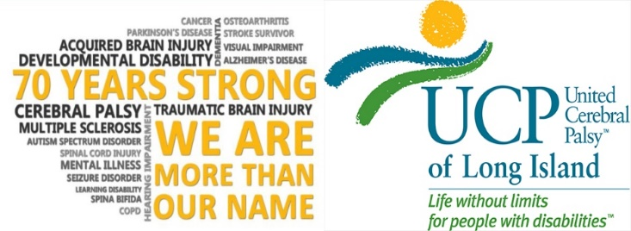

**UCP of Long Island Welcomes**

**New Director of Nursing Alisa Charles**



Hauppauge, NY (August 5, 2021) – UCP of Long Island is pleased to announce the appointment of Alisa Charles as the new Director of Nursing.

In this role, Ms. Charles will have responsibility for the supervision of 31 Intermediate Care Facilities (ICFs) and Individualized Residential Alternatives (IRAs) and all-day program nursing staff. Ms. Charles joins UCP of LI from Lifespire, INC. where she held the Director of Nursing position. Prior to joining Lifespire, INC. she held a Director of Medical Services role with the Jewish Board.

“We are delighted to have someone with Alisa’s experience join the leadership team here at UCP-LI. She is a seasoned medical profession with a strong background in the nursing industry. We believe she is well equipped to work with our team and lead us in our efforts to provide the highest quality of care to the individuals we support”, said Colleen Crispino, President and CEO.

Alisa has more than 15 years of experience; she is a dedicated professional with a demonstrated record of strong leadership skills including Supervision of Nursing Staff, Oversight of Continuity of Individual Care, Training and Communication. Ms. Charles holds a Master’s Degree in Health Administration from Central Michigan University and a Bachelor’s Degree in Health Administration from St. Joseph’s College. She received her Registered Nursing degree from Helene Fuld College of Nursing.

“I am truly humbled to join UCP of Long Island and I look forward to working closely with the agency to further our mission to create a ***LIFE WITHOUT LIMITS*** for those in our care”, said Alisa.

To learn more about UCP of Long Island, please visit [www.ucp-li.org](http://www.ucp-li.org)

*For over 70 years, United Cerebral Palsy of Long Island has positively impacted the lives of people with disabilities through the outstanding quality of our programs and services and the compassion we convey to those we serve. UCP of Long Island is committed to advancing the independence, productivity and full citizenship of people with disabilities by creating* ***Life Without Limits****. Our heartfelt mission is to provide life skills training, education, advocacy, meaningful employment and a place to call home for Long Islanders with a wide range of disabilities. UCP of Long Island proudly upholds the values of excellence, integrity, dignity, empowerment, responsibility, accountability, vision and innovation. For information on UCP of Long Island programs and services, please visit www.ucp-li.org*.